Ideation Phase
Brainstorming & Idea Prioritization

Date
Student ID | 23NU1A4221
Project Name | Metro ticket Generating system in ServiceNow
Maximum Marks | 2 Marks

1. Idea Generation
Based on the identified passenger problems, the following ideas were generated:

No. | Idea | Purpose
1 | Service Catalog Item for Ticket Booking | Allow passengers to request metro tickets through a structured booking form.
2 | Source, Destination, Passenger Type & Number of Tickets | Capture the required journey and passenger details.
3 | Automated Fare Calculation | Calculate the ticket fare based on the selected source and destination.
4 | QR Code Generation | Generate a digital QR-based ticket after successful booking.
5 | Digital Payment Integration | Support convenient payment methods such as UPI and cards.
6 | Admin Dashboard | Provide booking and transaction information for monitoring and analysis.

Brainstorming Board
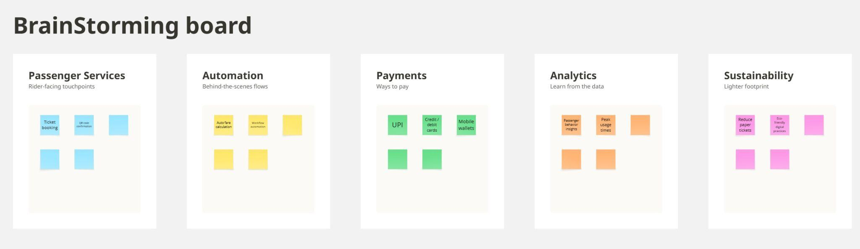Reference https://miro.com/app/board/uXjVHnsmcmM=/?share_link_id=796824267924

2. Idea Grouping
The generated ideas were grouped into the following categories:

Category | Ideas
Passenger Services | Service Catalog ticket booking, Source, Destination, Passenger Type, Number of Tickets
Automation | Automated fare calculation, automated ticket generation
Payments | UPI and card payment integration
Analytics | Admin dashboard, booking and transaction data
Sustainability | Digital tickets, reduced dependency on paper tickets
3. Idea Prioritization
The ideas were evaluated based on Impact and Feasibility
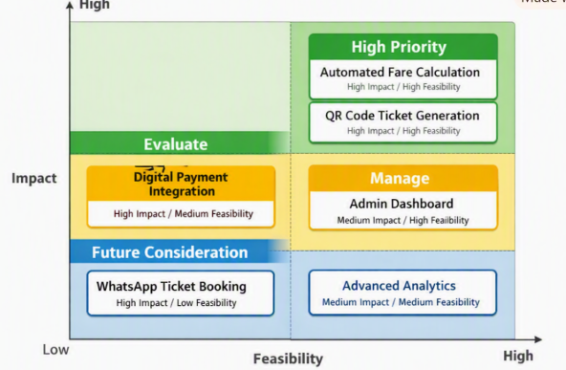

Impact–Feasibility Prioritization Matrix

4. Final Selected Ideas
Based on the prioritization, the following ideas were selected for the project:
1. Service Catalog Ticket Booking
2. Automated Fare Calculation
3. QR Code Digital Ticket Generation
4. Digital Payment Support
5. Admin Dashboard

Final Decision
The project will primarily focus on simplifying metro ticket booking, automating fare calculation, generating digital QR tickets, and supporting convenient digital payments. An admin dashboard will provide basic monitoring and analytics. WhatsApp ticket booking and advanced analytics are considered future enhancements.

